DAY- 12   
  
Name -Rishabh Manchanda

Employee id- 109883998

Task 1:

What do you understand about data structures?

the purpose of data structures is to provide a framework for organizing and managing data efficiently. They play a critical role in software development, enabling developers to create efficient algorithms, manage memory effectively, and solve complex problems. Understanding data structures is essential for building robust, scalable, and high-performance applications.

Task 2:

What are the types of data structures you know .. list them out.. ?

Data structures can be classified into several types eg; Primitive data structures - Arrays, linked list , Stacks and queues , Graphs, Hash , Non- Primitive data Structures.

Task 3 ;

What all operations can we do in Data structures?

data structures support a wide range of operations that enable the efficient management and manipulation of data. The choice of data structure and the operations performed on it can significantly impact the performance and efficiency of algorithms and applications. Eg; Creation, Insertion,Deletion ,Traversal, Sorting and merging ,etc.

Task 4:

What are static and dynamic arrays? Explain or summarize key points in a table like

Size, performance, memory, flexibility, limitations

| **Feature** | **Static Arrays** | **Dynamic Arrays** |
| --- | --- | --- |
| Size | Fixed size, determined at compile time. | Size can be changed at runtime. |
| Performance | Generally faster due to contiguous memory allocation and no overhead for resizing. | May have overhead due to resizing and memory allocation. |
| Memory | Allocated on the stack (for local arrays) or in a fixed memory location. | Allocated on the heap, allowing for larger sizes but requiring manual memory management. |
| Flexibility | Less flexible; cannot change size after creation. | More flexible; can grow or shrink as needed. |
| Limitations | Limited by the initial size; may lead to wasted space if not fully utilized. | Requires careful management of memory; potential for fragmentation and overhead during resizing. |

Task 5:

What is the binary value of a?

The binary value of the character 'a', with an ASCII value of 97, is 01100001.   
  
  
  
  
Task 6:

Types of Computer memory with examples.. Explain ..

Computer memory can be broadly categorized into primary (or main) memory and secondary memory. Primary memory, like RAM and ROM, provides quick access to data for the CPU, while secondary memory, like hard drives and SSDs, offers long-term storage. Within these categories, different types of memory serve specific purposes based on speed, capacity, and data retention.

Task 7;  
  
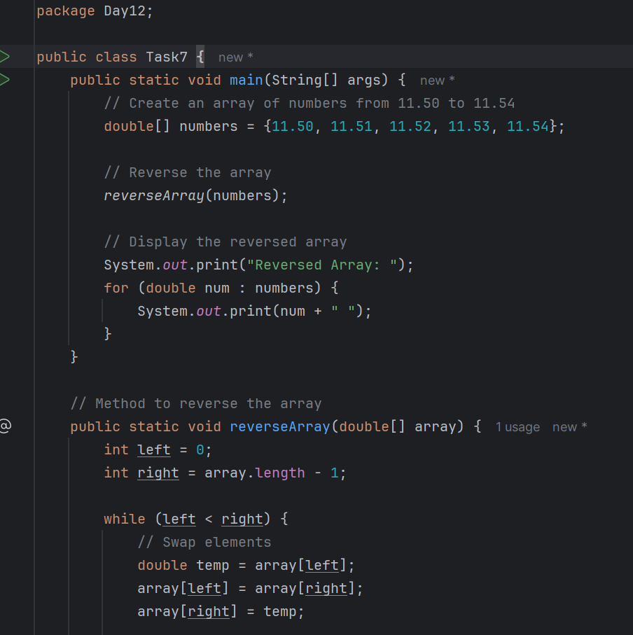

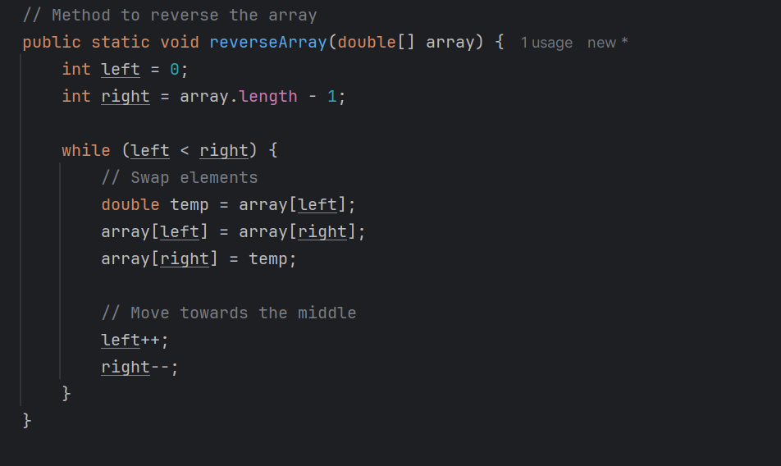

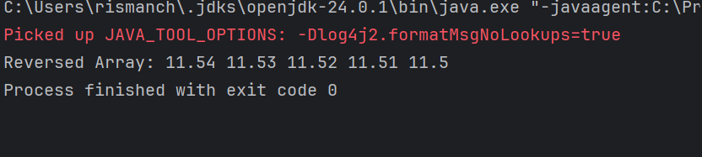

TASK 8

Reverse a string .. write a code.

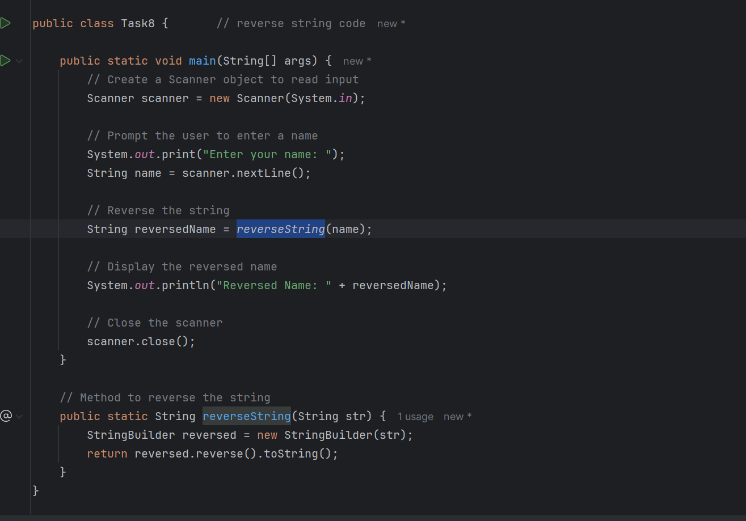

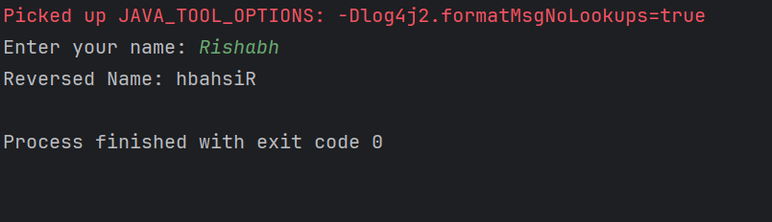

Task 10-

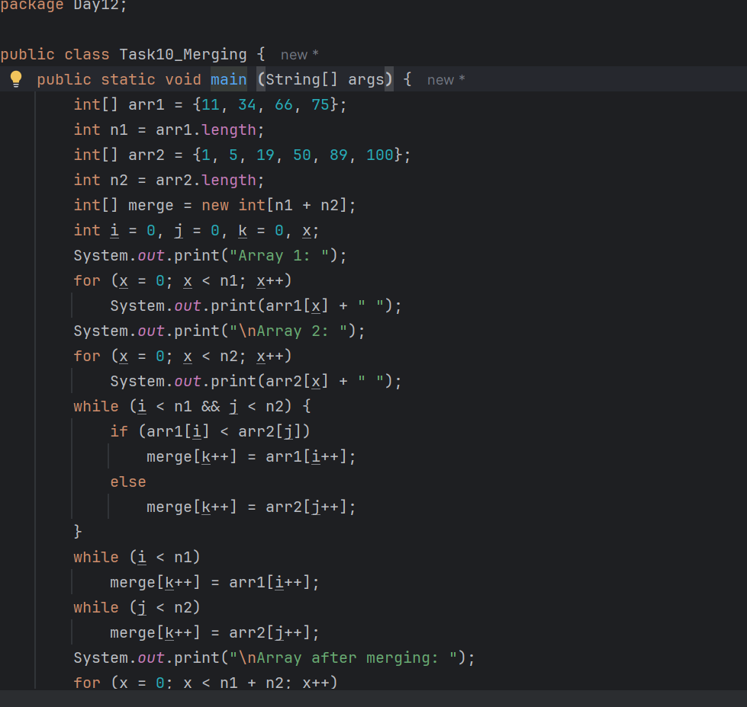

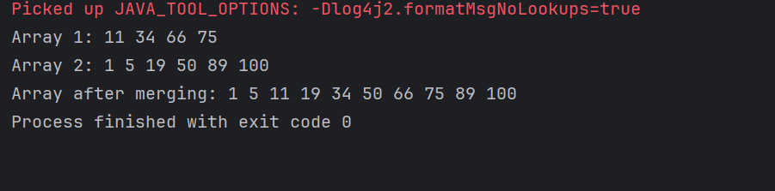

Task 11:

What do you understand by Hash table?

A hash table is a data structure that implements an associative array, a structure that can map keys to values. It uses a hash function to compute an index (or hash code) into an array of buckets or slots, from which the desired value can be found.

Task 12-

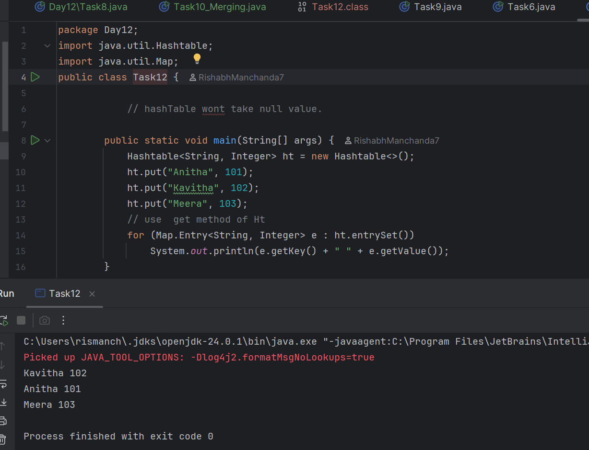

Task-13

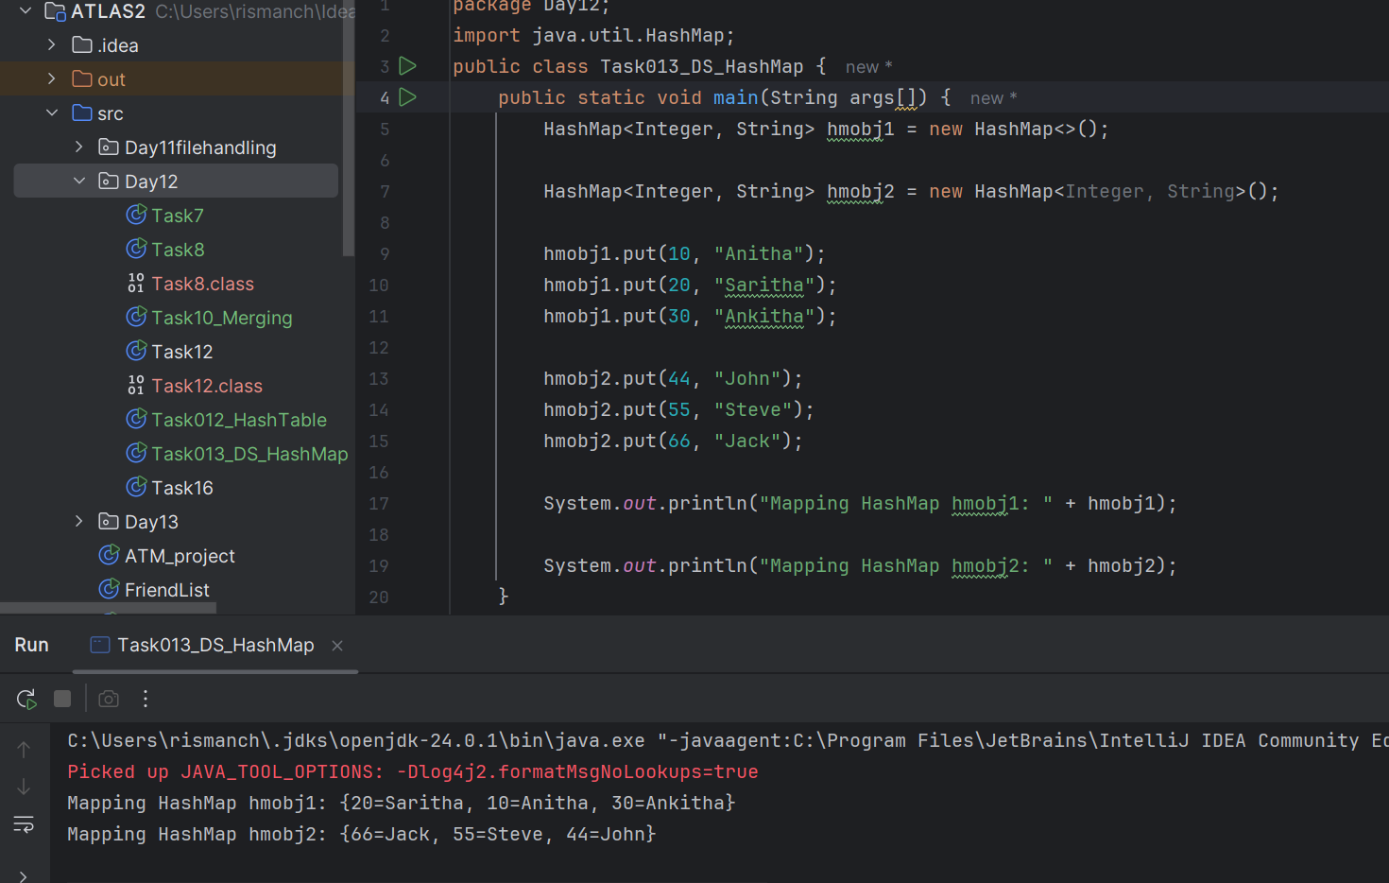

Task -16

